Design And Implementing Heart Disease Prediction Using Naives Bayesian

In this paper author using Naïve Bayesian machine learning algorithm to predict heart disease by training algorithm with UCI heart disease dataset and this paper implementing following modules

- User registration: allow user to register with app
- User Login: allow user to login with the application
- Predict disease: After login user can input various details such as cholesterol level, blood sugar, age sex etc.

User will input following details

age,sex,cp,trestbps,chol,fbs,restecg,thalach,exang,oldpeak,slope,ca,thal

screen shots

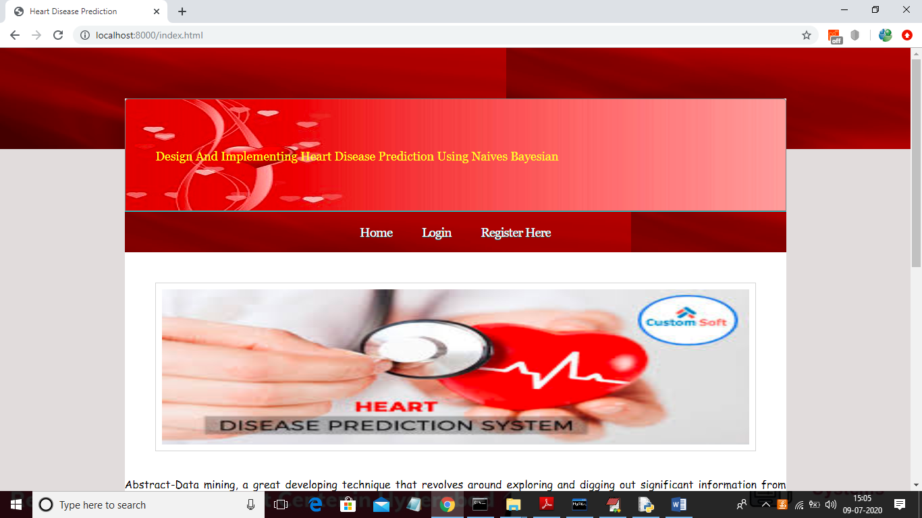

Click on ‘Register Here’ link to add new user
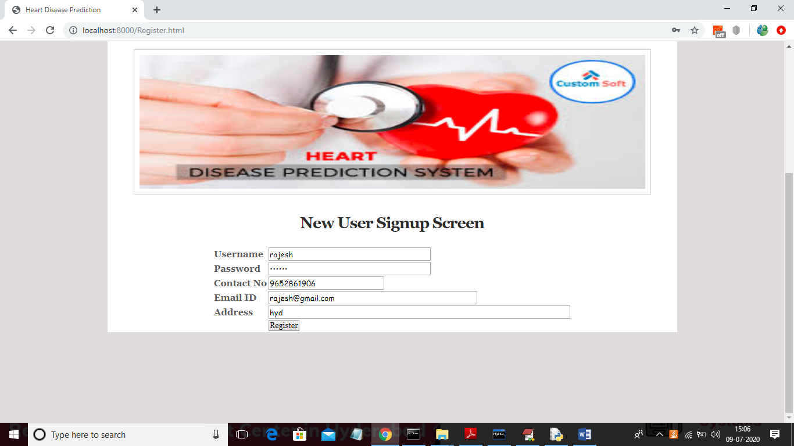
After adding new user will get below screen
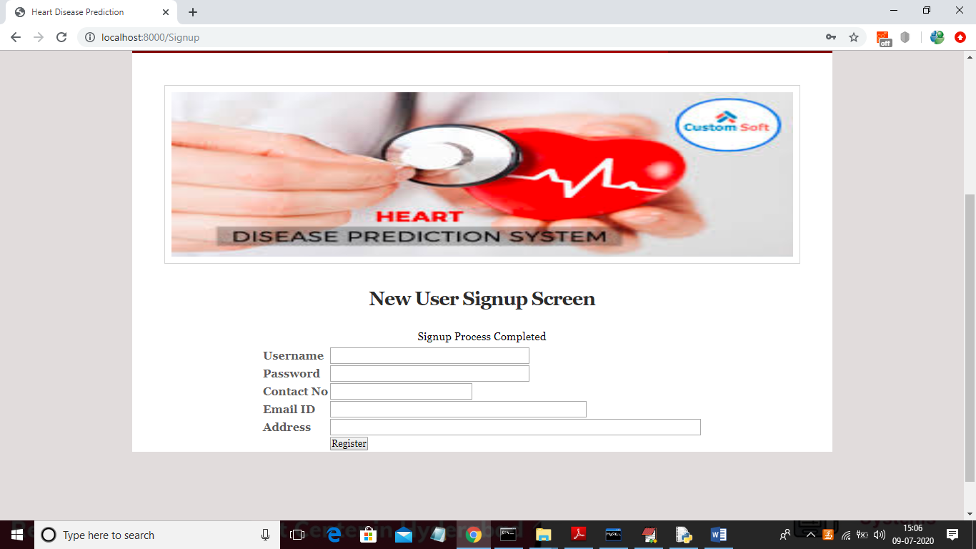
Now click on login link to log user
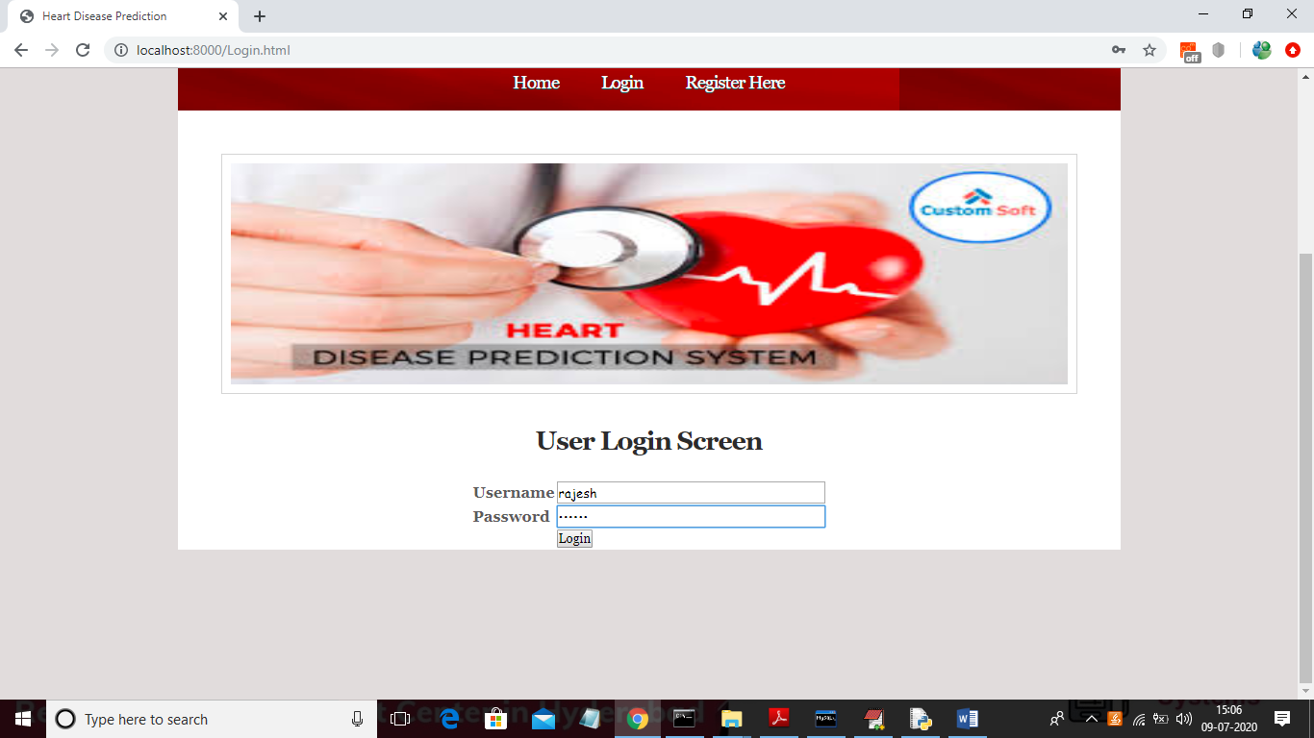
After login will get below screen
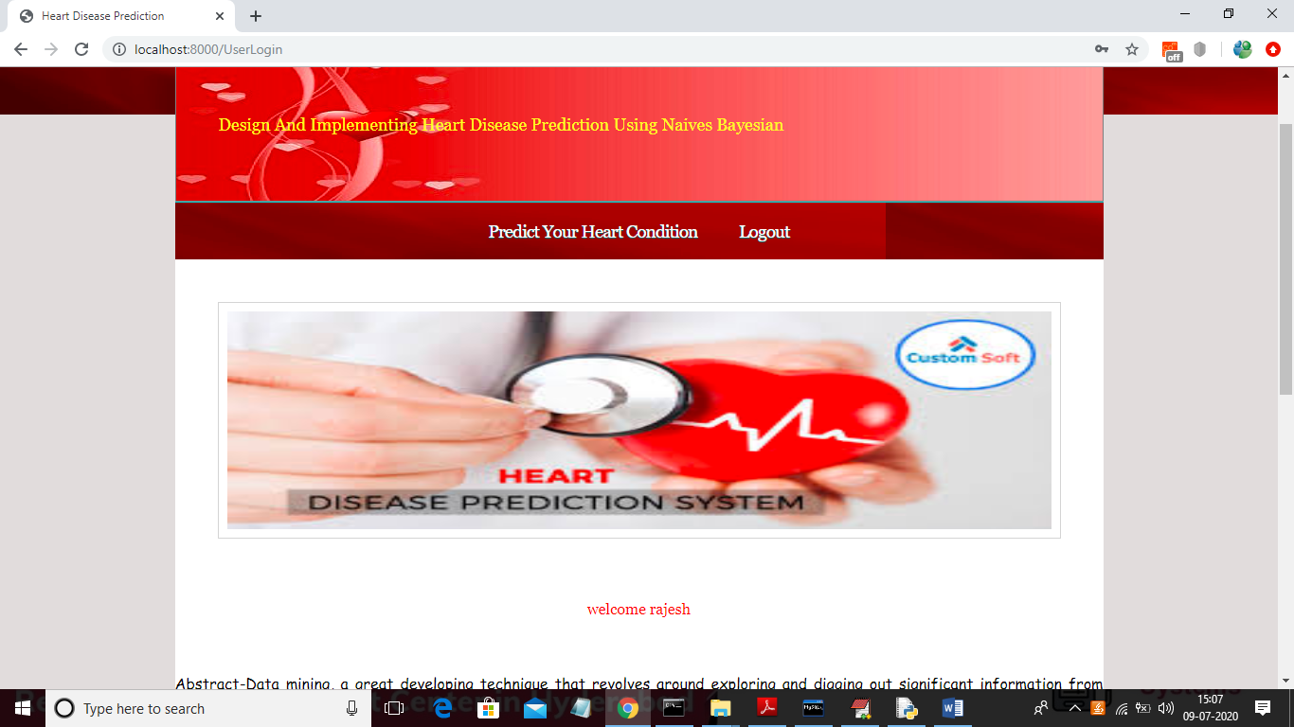
Now click on ‘Predict Your Heart Condition’ link to input details
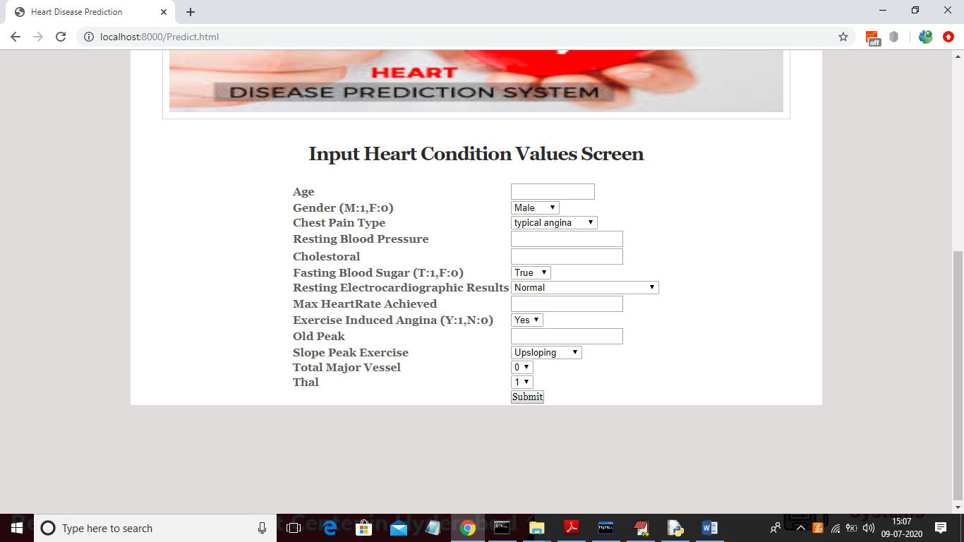
In above screen user will enter details about his heart and application will predict disease

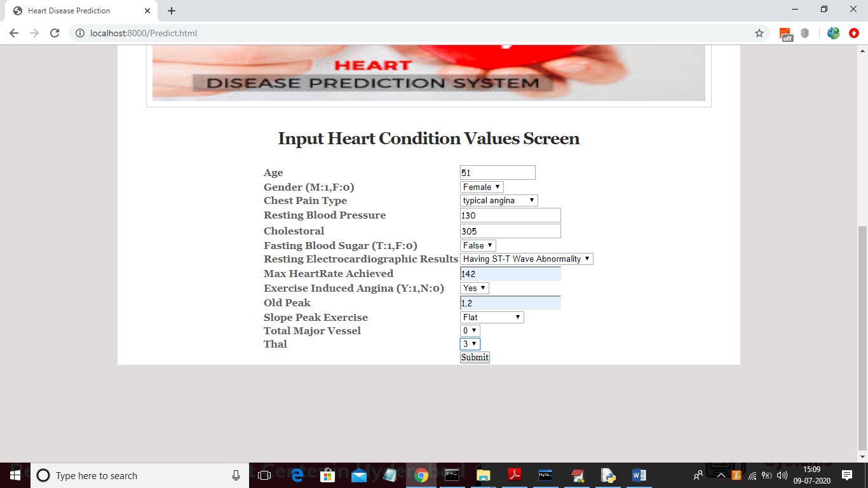
In above screen after entering details will get below screen of prediction
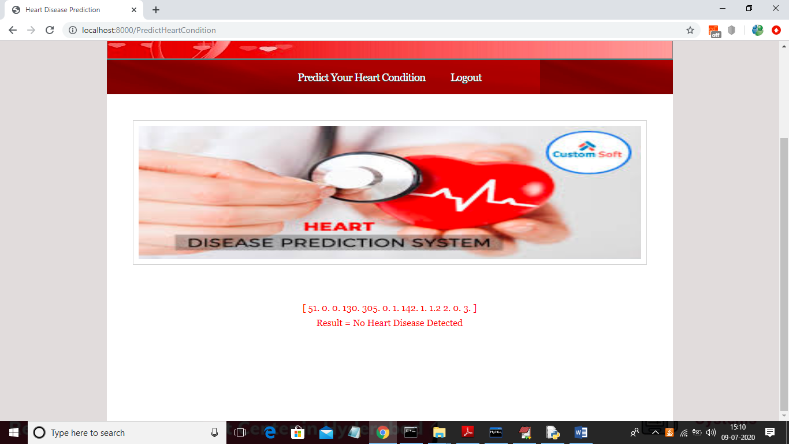
Now below screen with different data

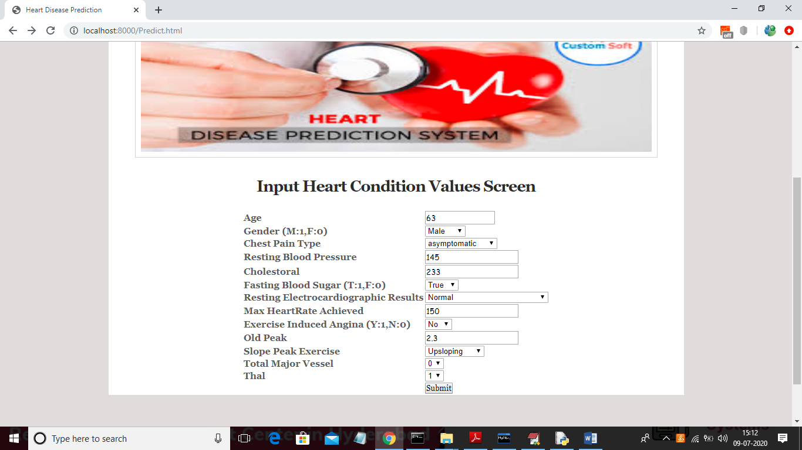
For above screen data will get below result
